##### 

**A**

**MINI PROJECT REPORT**

**ON “NIPAH VIRUS TESTING SYSTEM”**

**TO SUBMITTED**



**SAVITRIBAI PHULE PUNE UNIVERSITY, PUNE**

**FOR THE PARTIAL FULLFILLMENT OF THE DEGREE OF**

**B.B.A.(COMPUTER APPLICATION**

**SUBMITTED BY**

**AHER PALLAVI BHASKAR**

**MORE POOJA RANGNATH**



**B.Sc. (Home Sci.)&B.C.A Women’s College Kopargaon**

**TAL-Kopargaon, DIST. - Ahmednagar.**

**SAVITRIBAI PHULE PUNE UNIVERSITY**

**2023-24.**

**CERTIFICATE**

**This to certify that the**

**Project Report entitles**

**“NIPAH VIRUS TESTING”**

**SUBMITTED BY**

**AHER PALLAVI BHASKAR**

**MORE POOJA RANGNATH**

**Seat Number -2, 24**



**Seat Number-2, 24**

**Is a bonafide student of this institute and the work has been carried out by her under the supervision of Prof.<guide name> and it is approved for the partial fulfillment of the requirement of Savitribai Phule Pune University, for the award of the degree of B.B.A.(Computer Application)**

**(Internal Guide) (HOD) Principal**

**Prof. Saiprasad Dr. Manojkumar.**

**Khardekar S.Langote**



**SAVITRIBAI PHULE PUNE UNIVERSITY, PUNE**

CERTIFICATE

**This to certify that**

**AHER PALLAVI BHASKAR**

**MORE POOJA RAMGMATH**

**Seat Number -2, 24**

**Student of Third Year B.B.A. (Computer Application)**

**Was examined in Project Report entitled**

**“NIPAH VIRUS TESTING”**

**On - / /**

**At**

**B.Sc. (Home Sci.) & B.C.A Women’s College Kopargaon**

**(Internal Examiner) (External Examiner)**

**DECLARATION**

I am **AHER PALLAVI & MORE POOJA** hereby declare that the work included in this project report entitled **NIPAH VIRUS TESTING** is carried out by me Under the guidance of **Miss Pandure P.B, Shelke S.V. & Bothe mam**

Assistant professor of department. The department OF BBA (CA) (Computer Application) (BSc. Home sci. and BCA Women’s College Kopargaon).

This project is my own work, based on my personal study and/or research and that I have acknowledged all material and sources used in its preparation, whether they be books, articles, reports, lecture notes, and any other kind of document, electronic or personal communication.

**Place: Kopargaon**

**Student name &signature**

**Date:**

ACKNOWLEGMENT:

The acknowledgment is jaust drop of the sense of gratitude within our hearts for the people who help us out of the most embarrassing part of life when we are standing on the last and most difficult step towards our of life.

We take immense pleasure in thanking our project Guide who is prof. Miss. Pandure P.B ,Shelke S.V. ,Bothe mamS for having permitted us to carry our thi project work and for this valuable guidance and also useful suggestions,which halped us in completing the project work,in time.

We wish to express our deep sense of gratitude towards the needless to mention that prof. Miss. Pandure P.B., BOTHE MAM & Shelke S.V. project coordinator who had been a source of inspiration and for his timely guidance in the conduct of our project work and for all their valuable assistance in the project work.

We greatly thanks to our **Miss**. Pandure P.B .BOTHE MAM & Shelke S.V. Principal, **and principle:**  and **Prof. Mr. Khardekar Sir** for giving there constant guide.

Finally, yet importantly,we would like to express our heartfelt thanks to our beloved parents for their blessings our friends/classmates for their help and wishes for the successful completion of this project.

##### 

1. **INTRODUCTION**
   1. Introduction
   2. Needs of the project
   3. Objectives of project
   4. Scopes of the project
   5. Modules in the project
2. **REQUIREMENTS SPECIFICATION**
   1. Introduction
   2. Hardware requirements
   3. Software requirements
3. **SYSTEM ANALYSIS**
   1. Existing System
   2. Proposed System
   3. Feasibility study
   4. Fact finding technique
      1. Interviewing
         1. Structured Interview & b) Unstructured Interview
      2. Questionnaires
      3. Observation
      4. Record View
4. **SYSTEM DESIGN**
   1. Entity Relationship Diagram
   2. Data Flow Diagram
   3. Data Dictionary
5. **SYSTEM TESTING**

5.1. Software testing

5.2 testing methods 5.2.1White box testing

5.2.2 Black box testing

1. **ADVANTAGES AND LIMITATIONS CONCLUSION**

**7. BIBLIOGRAHY**

# CHAPTER 1

# 

# INTRODUCTION

In this project, we use **PHP**and **MySQL**database. It has two modules

1. Admin
2. User(Patients)

* **Admin Module:**

Admin is the superuser of the website who can manage everything on the website. Admin can log in through the login page

* **Dashboard:** In this section, the admin can see all detail in brief like the total, assigned and the sample collected and completed tests.
* **Phlebotomist:** In this section, the admin can manage Phlebotomist (add, update, delete).
* **Testing**: In this section, the admin can manage all the tests like assign the test to Phlebotomist and update the history.
* **Report:**In this section, the admin can generate two types of report. One is between dates reports and another one is by search. Admin can search the report by order number, name and mobile number.
* **Notification:** In this section, the admin will get a notification for every new test request (notification bell).

Admin can also update his profile, change the password and recover the password.

* **User (Patient) Module**

User can visit the application through a URL.

* **Testing:** This section divided into two parts. One is for new user and another one is for registered user. New user (First-time user) needs to provide personal and testing Information. A registered user only needs to provide test information, their personal information will be fetched from the database.
* **Report:** In this section, Users can search their test report using order number, name and registered mobile number.
* **Dashboard:**In this section, the User can see the in which State of how many tests are done

## 1.1 MODULES IN THE PROJECT

The entire project mainly consists of 2 modules, which are

* + Admin module
  + User module

**CHAPTER 2**

# REQUIREMENT SPECIFICATION

## INTRODUCTION

To be used efficiently, all computer software needs certain hardware components or the other software resources to be present on a computer. These pre-requisites are known as (computer) system requirements and are often used as a guideline as opposed to an absolute rule. Most software defines two sets of system requirements: minimum and recommended. With increasing demand for higher processing power and resources in newer versions of software, system requirements tend to increase over time. Industry analysts suggest that this trend plays a bigger part in driving upgrades to existing computer systems than technological advancements.

They are usually of two types

1. Hardware Requirements
2. Software Requirements

### **HARDWARE REQUIREMENTS**

The most common set of requirements defined by any operating system or software application is the physical computer resources, also known as hardware. A hardware requirements list is often accompanied by a hardware compatibility list (HCL), especially in case of operating systems. An HCL lists tested, compatibility and sometimes incompatible hardware devices for a particular operating system or application. The following sub-sections discuss the various aspects of hardware requirements.

**Hardware Requirements for present project:**

|  |  |  |
| --- | --- | --- |
| **1.Processor** | **:** | Intel® core ™ i5 |
| **2.RAM** | **:** | 8GB |
| **3.Hard Disk** | **:** | 160GB & Above |
| **4.Monitor** | **:** | VGA/SVGA |
| **5.Printer** | **:** | Inkjet |
| **6.Mouse** | **:** | Optical Mouse |

### **SOFTWARE REQUIREMENTS**

Software Requirements deal with defining software resource requirements and pre-requisites that need to be installed on a computer to provide optimal functioning of an application. These requirements or pre-requisites are generally not included in the software installation package and need to be installed separately before the software is installed.

|  |  |  |
| --- | --- | --- |
| **Operating System** | **:** | Windows XP or Above |
| **Front End** | **:** | HTML, CSS, JAWA SCRIPT. |
| **Back End** | **:** | MySQL |
| **Server Side Script** | **:** | PHP |

**CHAPTER 3**

# SYSTEM ANALYSIS

## EXISTING SYSTEM

Hospitals currently use a manual system for the management and maintenance of critical information. The current system requires numerous paper forms, with data stores spread throughout the hospital management infrastructure. Often information is incomplete or does not follow management standards. Forms are often lost in transit between departments requiring a comprehensive auditing process to ensure that no vital information is lost. Multiple copies of the same information exist in the hospital and may lead to inconsistencies in data in various data stores.

## PROPOSED SYSTEM

The Hospital Management System is designed for any hospital to replace their existing manual paper-based system. The new system is to control the information of patients. The services

are to be provided in an efficient, cost effective manner, with the goal of reducing the time and resources currently required for such task.

The main purpose of our system is to make hospital take easy and is to develop software that replaces the manual hospital system into automated healthcare management system.

## FEASIBILITY STUDY

The feasibility of the project is analyzed in this phase and business proposal is put forth with a very general plan for the project and some cost estimates. During system analysis the feasibility study of the proposed system is to be carried out. This is to ensure that the proposed system is not a burden to the company. For feasibility analysis, some understanding of the major requirements for the system is essential.

Three key considerations involved in the feasibility analysis are:

### **Economic Feasibility**

This study is carried out to check the economic impact will have on the system will have on the organization. The amount of fund that the company can pour into the research and development of the system is limited. The expenditures must be justified. Thus, the developed system as well within the budget

and this was achieved because most of the technologies used are freely available. Only the customized products have to be purchased.

### **Technical Feasibility**

This study is carried out to check the technical feasibility, that is, the technical requirements of the system. Any system developed must not have a high demand on the available technical resources. This will lead to high demands being placed on the client. The developed system must have a modest requirement, as only minimal or null changes for the implementing this system.

### **Operational Feasibility**

The aspect of study is to check the level of acceptance of the system by the user. This includes the process of training the user to use the system efficiently. The user must not feel threatened by the system, instead must accept it as a necessity. The level of acceptance by the users solely depends on the methods that are employed to educate the user about the system and to make him familiar with it. His level of confidence must be raised so that he is also able to make some constructive criticism, which is welcomed, as he is the final user of the system.

# FACT FINDING TECHNIQUE

When information gathering is large & complex organization is not an easy task, then fact finding technique is use. There are four fact finding techniques, but we use their fact finding technique for gathering information. We are preparing of project based on collection of information & handle the information regarding particular Hospital Management System. There are some fact finding techniques.

### **INTERVIEWING:**

We use this technique frequently in the system Analysis because this technique is best method for producing the qualitative information & allow us to discover areas of misunderstanding unrealistic expectation to the proposed system, the interview is structure and unstructured. Analysis uses interview to collect information from individual. There are two types of interview:

##### Structured interview:

Structured interview involved question which are out & followed thoroughly. Each candidate is presented with the same question & this insures that each respondent has the

Opportunity to each question. There is limited time. It includes hard study.

##### Unstructured interview

An unstructured interview is an interview without set format but in which the interview may have some key question formulated in advance.

### **QUESTIONNAIRES**

A from containing a set of question, especially one addressed to statistically significant number of subjects as a way of gathering information for a survey. Questionnaires may be used as a supplement to the interviews. We have questionnaires fact finding technique fir gathering numerical data & opinion.

### **OBSERVATION**

Observation is most useful when analyst need to be actually observed how document are handle, how process is carried out & whether specified steps are actually followed or not. Observation provide close view of working of the real system analyst observe people, object, document & occurrences of event. Observation

Allow analyst to get information, which cannot obtain by any other fact finding technique.

### **RECORD REVIEW:**

The record review can take place of the beginning of the system study. Man, record can provide information valuable information about organization.

**CHAPTER 4**

# SYSTEM ANALYSIS

### **ENTITY RELATIONSHIP DIAGRAM**

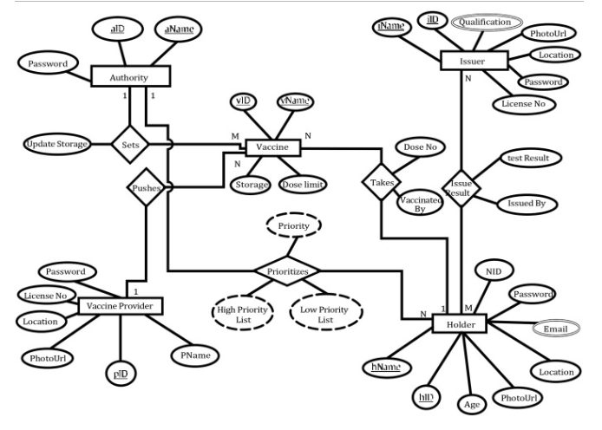

* 1. **ClASS DIAGRAM**

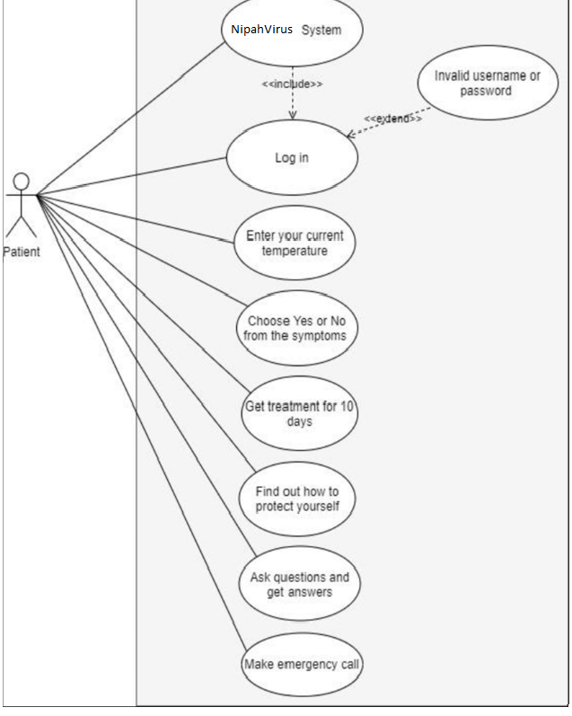

* 1. **DIAGRAM**

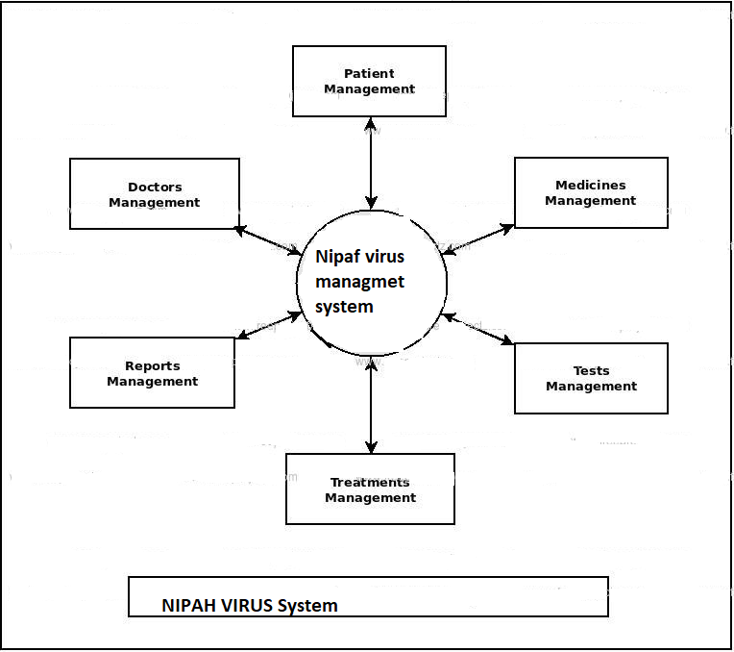

### **4.4 SCREEN SHOT**

### **HOME**

### 

### **ADMIN LOGIN**

### 

### **ADMIN DASHBOARD**

### 

### **All TEST REPORT**

### **TESTING:-**

### 

### **TEST REPORT:-**

### 

### **SAMPLE SEND IN LAB:-**

### 

# 

# TOTAL REGISTERED PHLEBOTOMIST:-

# 

# REPORT DELIVERS TEST

### **4.5 DATA DICTIONARY**

**DATABASE TABLE:-**

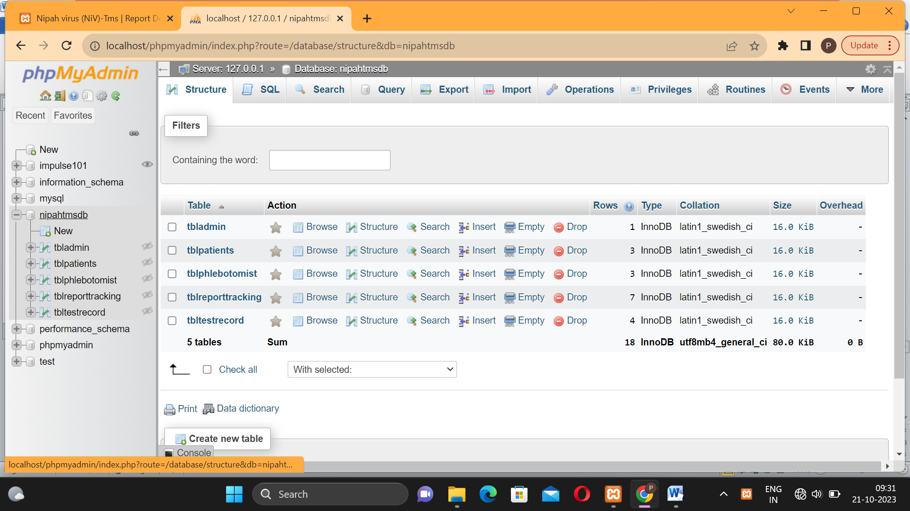

**ADMIN TABLE-:**

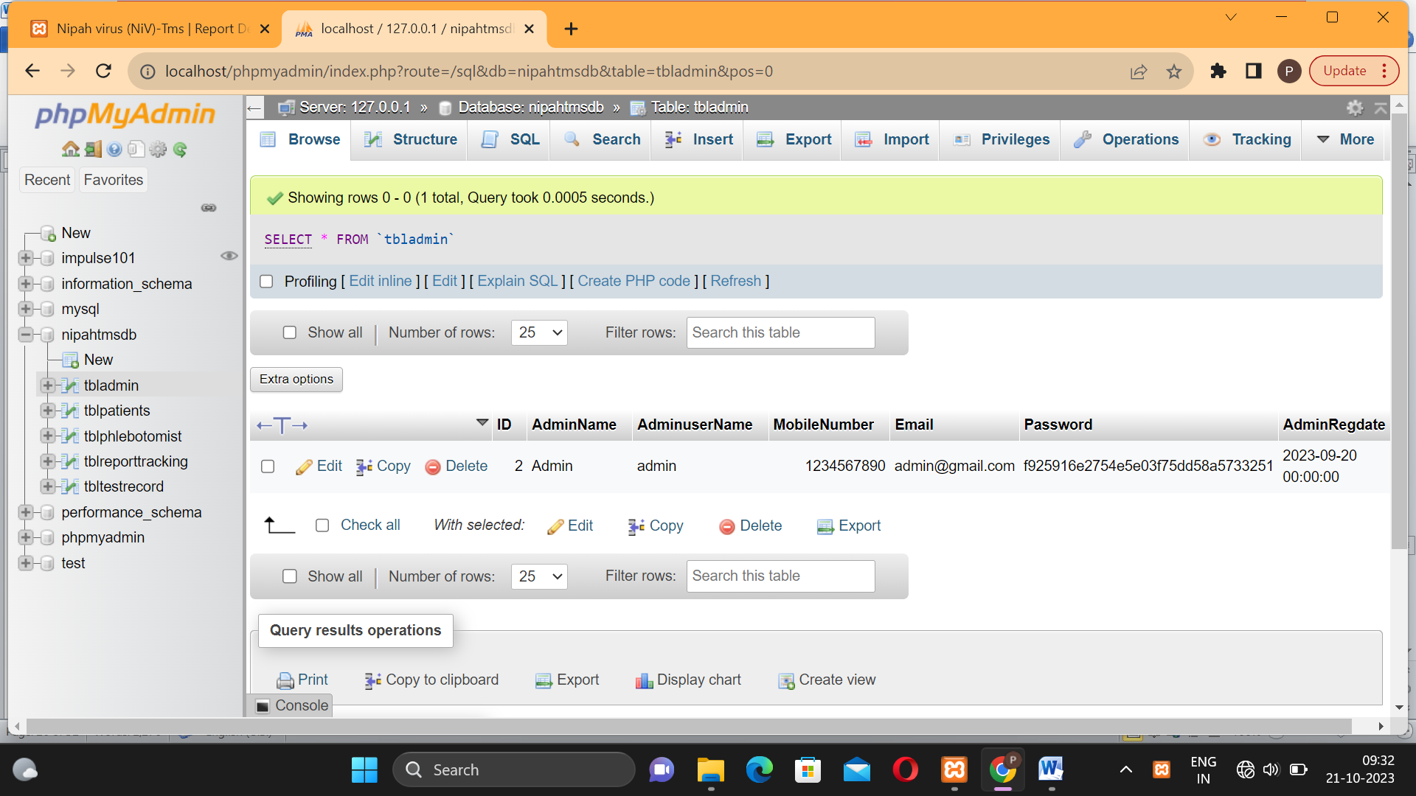

**PATIENT TABLE-:**

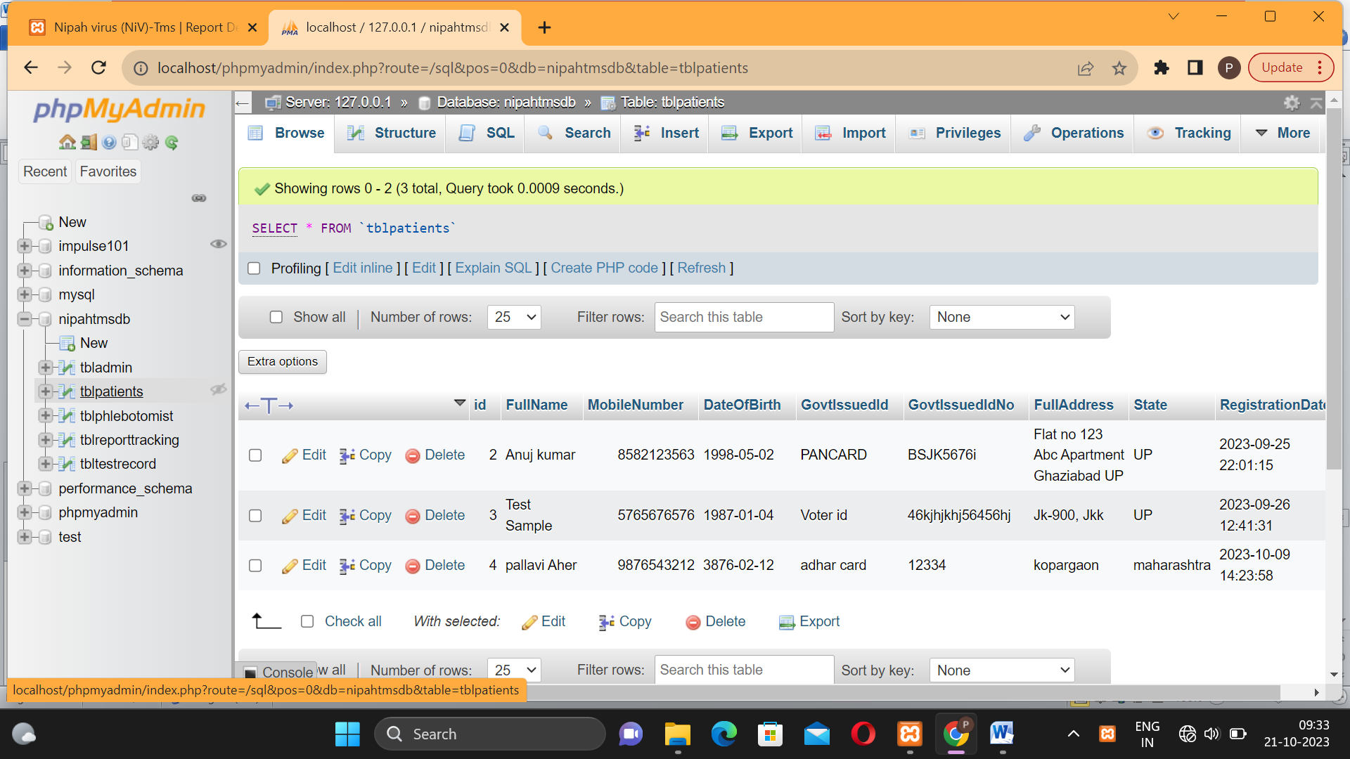

[**Table: tblphlebotomist**](http://localhost/phpmyadmin/index.php?route=/sql&db=nipahtmsdb&table=tblphlebotomist)

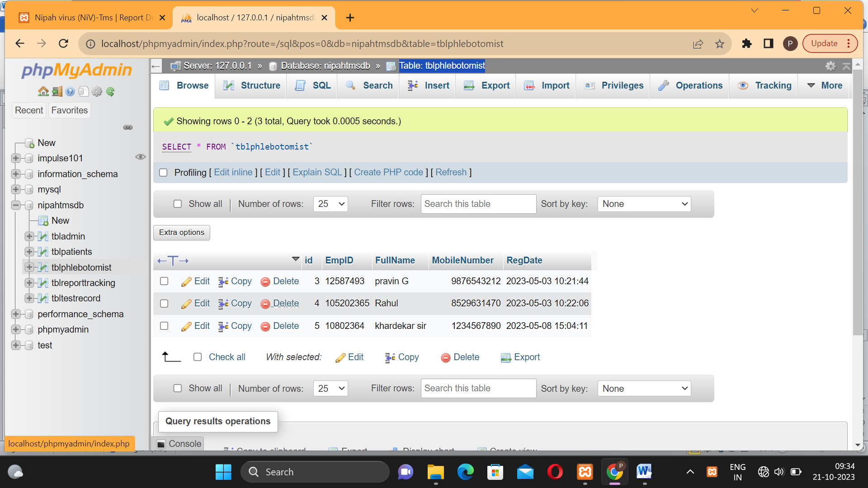

**RECORD:-**

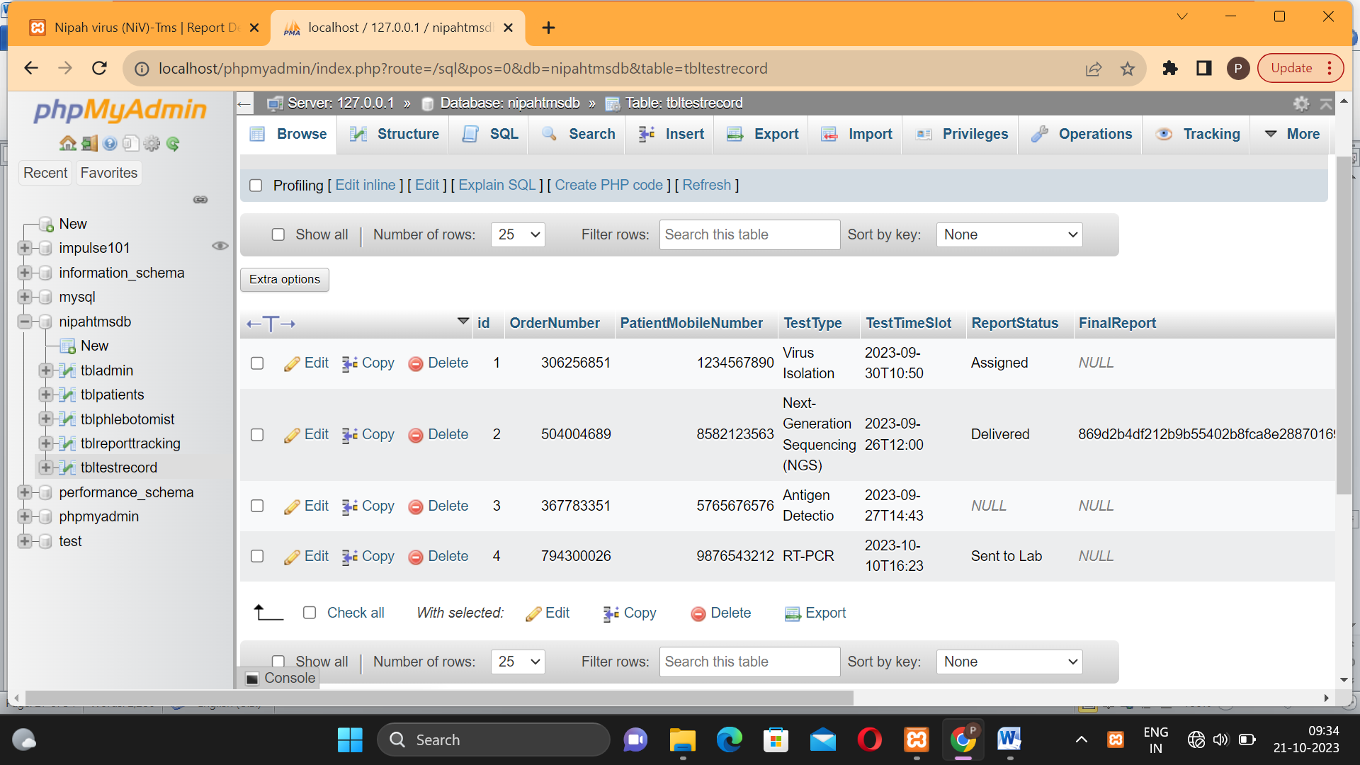

**CHAPTER 5**

# SYSTEM TESTING

### **SOFTWARE TESTING**

Is all the link of website that works done properly? All input type that work properly or not & button that work or not or data feeding is properly operation and Tool-bars work properly? Is it possible to invoke each function using logical assumptions that if all parts of the system are correct, the goal will be successfully achieved? The testing process focuses on the logical intervals of the software ensuring that all statements have been tested and on functional interval is conducting tests to uncover errors and ensure that defined input will produce actual results that agree with the required results. Program level testing, modules level testing integrated and carried out.

There are two major type of testing they are

* + 1. White Box Testing
    2. .Black Box Testing.

### **WHITE BOX TESTING:**

White box sometimes called “Glass box testing” is a test case design uses the control structure of the procedural design to drive test case.

A) All independent paths within a module have been exercised once. In our system, ensuring that case was selected and executed checked all case structures. The bugs that were prevailing in some part of the code where fixed

b) All logical decisions were checked for the truth and falsity of the values.

### **5.1.2 BLACK BOX TESTING:**

Black box testing focuses on the functional requirements of the software. This is black box testing enables the software engineering to derive a set of input conditions that will fully exercise all functional requirements for a program. Black box testing is not an alternative to white box testing rather it is complementary approach that is likely to uncover a different class of errors that white box methods like.

1. Interface errors
2. Performance in data structure
3. Performance errors
4. Initializing and termination errors

**CHAPTER 6**

# ADVANTAGES & LIMITATIONS

##### 6.1ADVANTAGES

* + 1. Acquire the greater operating and processing speed.
    2. Able to fulfill more and more demands of User in comparatively less time with higher accuracy.
    3. Easy to manage individual information.
    4. System bounded by the constraints and requirements gives the better hopeful outcome and thus, reduces the expense on manual work.

##### LIMITATIONS

* + 1. Due to lack of time we could not offer more facilities.
    2. In our system no facility to maintain all information.

**CHAPTER 7**

# CONCLUSION -:

Since we are entering details of the patients electronically in the **NIPAH VIRUS Testing Management System**data will be secured. Using this application, we can retrieve patient’s history with a single click. Thus, processing information will be faster. It guarantees accurate maintenance of Patient details. It easily reduces the book keeping task and thus reduces the human effort and increases accuracy speed.

**CHAPTER 8**

# BIBLIOGRAPHY-:

#### 8.1IMPORTANT LINKS

* + - [**https://www.w3schools.com/**](https://www.w3schools.com/)
    - [**https://www.geeksforgeeks.org/**](https://www.geeksforgeeks.org/)
    - [**https://www.slideshare.net/**](https://www.slideshare.net/)
    - [**https://www.google.com/**](https://www.google.com/)

#### REFERENCE BOOKS

* + 1. Database Management System
    2. Oriented Software Engineering
    3. PHP In Action: Objects, Design, Ability
    4. Murach’s PHP and MySQL by Joel Murach